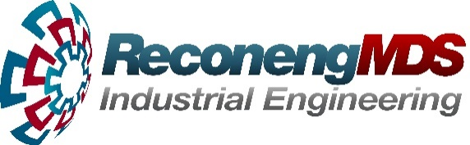
ProfiFeed Technologies, as a part of ReconEng group, is a World-leading supplier of linear positioning systems for industrial applications used in construction, manufacturing and other production industries.

ProfiStop (www.profistop.com) is our range of cutting automation products which we design, manufacture, distribute and sell in Europe, North America and Australia. Our engineering and manufacturing facilities are based in Krusevac, Serbia, and Melbourne, Australia.

We design, make, live and love our products and we pride ourselves on having an interesting, flexible and supportive workplace where our team like what they do as much as the owners. Our Company makes a strong commitment to its people and supports each and every employee as we work towards the goal of being the number one product in our market.
Due to strong growth in our EU business we are looking for a highly motivated sales employee for our office in Kruševac for the following position:

EU Sales Engineer

Main Tasks and Responsibilities:
- Researching on the internet and by phone Companies suitable for new distributorship opportunities for our products.
- Talking to potential new distributors on the phone, explaining the product and the business opportunities of our products.
- Visiting them to progress discussions, negotiating agreements for distribution with assistance of our managers.
- Signing new distributors into agreements along with large new orders for our products.
- Maintaining and growing the relationship with our current distributors (UK, Ireland, Holland, Belgium, Finland).
- Following up direct sales leads opportunities for small-order sales.
- Serbia-based, with requirement to travel Europe-wide as required.

Job Requirements:
- Fluent in speaking English, must be able to speak, write and understand English to a very high degree.
- Excellent phone skills. Ability to expertly make many phone calls and call and speak to anyone as required internationally.
- IT skilled with excellent knowledge of computers, email and Windows 10. Our product is software as well as machine and requires good computer skills to be able to show to Clients.
- Experience in business to business selling, selling machinery or other capital investment equipment.
- Ability to generate sales opportunities and get meetings with decision makers without much assistance.
- Proven business / sales / phone skills, strategic in approach to all work.
- Willingness to put in extra work to get the deal signed.
- Professional in presentation. Friendly, bright and enthusiastic, like the rest of the team!

What we offer:
- Above average salary looking for above average candidates.
- Zero employees leaving the Company in 6+ years.
- Long-term employment in a prestigious technology business.
- Job opportunity of a big town but with family lifestyle of a small town.
- Dynamic work in a pleasant and stimulating environment.
- Work directly with Directors of a fast-growing international business.
- Opportunities for personal and professional growth.
- Opportunities to travel to Europe, North America and Australia.
If you are interested in becoming a part of our team please send your resume.

